**Distribution of *Zea mays* under present and future climate conditions**

Name: Leon Bekooy s1501348

Date: 10-12-2017

**Introduction**

The human population is growing very fast, but all these people have to be fed. One crop that is often eaten by humans, but also by animals is *Zea mays*. *Z. mays* is a cereal belonging to the family of the Poaceae. *Z. mays* consists of four subspecies, namely domesticated *Z. mays* *mays* and three teosintes: *Z. m. huehuetenangensis*, *Z. m. mexicana*, and *Z. m. parviglumis.* The origin of *Z. mays* is in Mesoamerica. *Z. mays* is widespread over the world (fig. 1), but climate change can have effects on these distribution. We have to know what the effects of climate change are on *Z. mays* to know whether there will be *Z. mays* in the future and how much plants of these speciesthere will be. Therefor we are going to model the current distribution and the distribution in the future to make a future distribution change map for *Z. mays*.

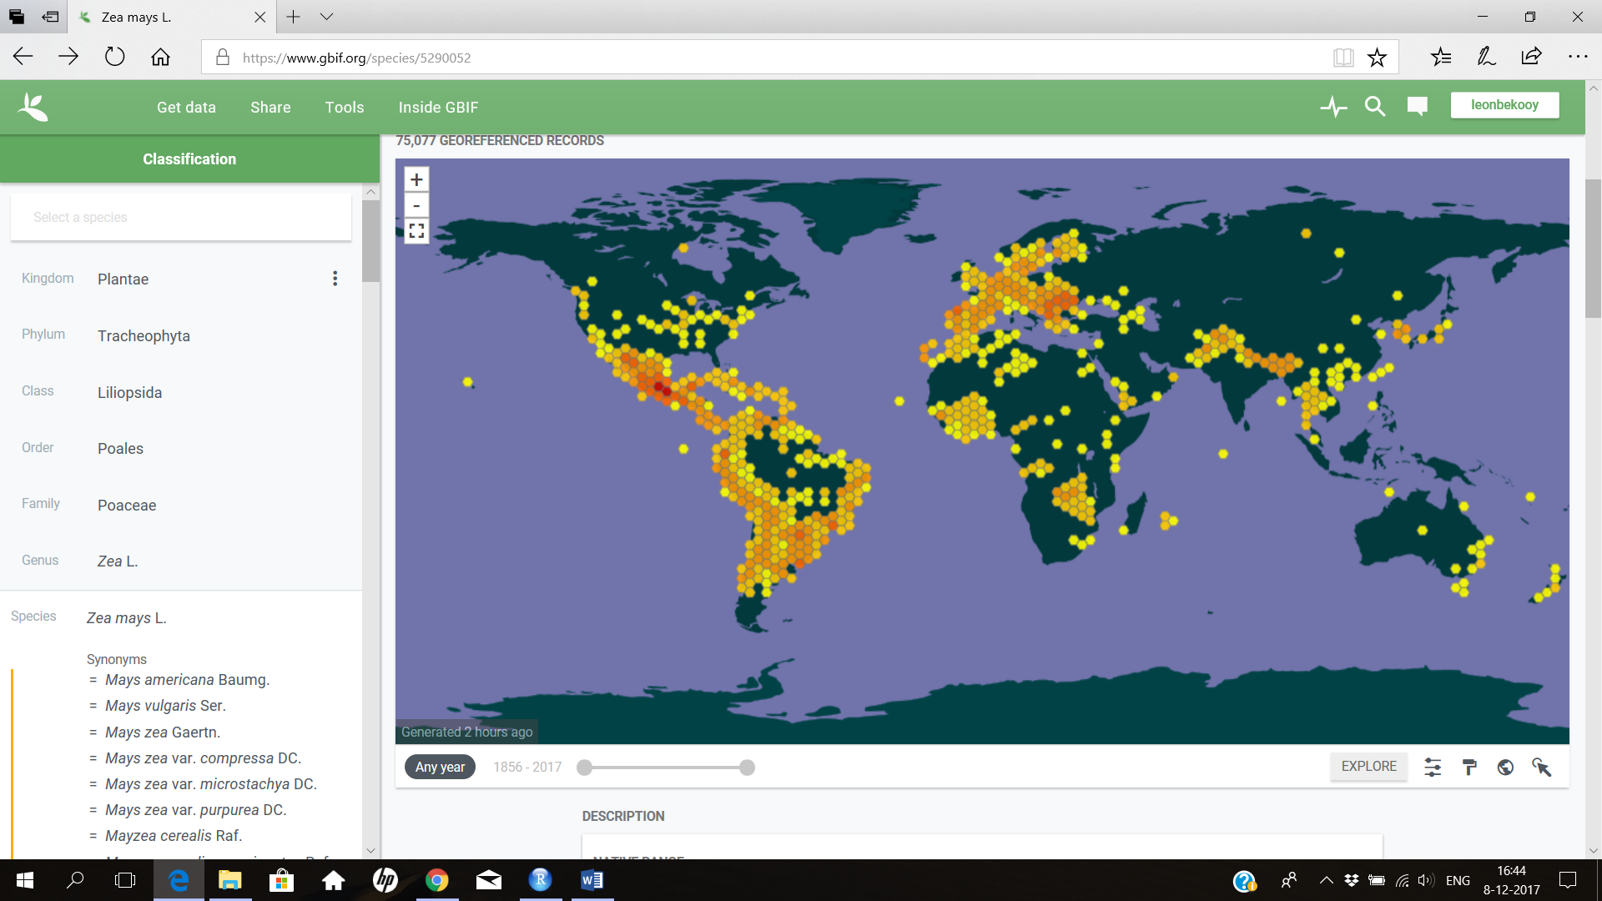

Fig. 1: 75.077 georeferenced records of *Z. mays* over the world over the years 1856-2017

**Methodology**

The methodology written in the manual ‘‘Model your chosen species’s habitat suitability under present and future climate conditions’’ is followed.

The future bioclims of 2050 under the scenario of RCP 4.5 from the model HadGEM2-AO were used. RCP 4.5 states that the radiative forcing will be stabilized at 4.5 W m−2 in the year 2100 without ever exceeding this level (Thomson et al, 2011). RCP 4.5 is chosen, because I expect that a lot of measures will be taken to decrease the CO2 emissions, however it will take some time, before the right measures are taken. The year 2050 is chosen, because the model prediction will be more certain than a model prediction for 2070 and the human population is already very big in 2050. So we need to know whether *Z. mays* will be present in 2050 and in which quantity.

Settings on MAXENT

Linear features and quadratic features were selected in MAXENT, because this should give the best model. Not selecting hinge, product and threshold features prevent over-parameterization (Merow et al. [2013](http://onlinelibrary.wiley.com/doi/10.1111/ecog.01509/full#bib-0043)). The rest of the settings was the same as in the manual, except for the max number of background points. These was set to 100.000 instead of 10.000 to have more background points than presence records.

Variable selection

Variable Bio2 mean diurnal range (mean of monthly (max temp – min temp)), Bio6 (min temperature of coldest month, Bio13 (precipitation of wettest month) and Bio14 (precipitation of driest month) were selected based on the spearman’s correlations (table 1) and on the importance for *Z. mays*. Bio2 is important for *Z. mays* by the temperature differences. If *Z. mays* has a broad temperature range in which it survives, than big temperature differences will affect the plants not very much, but if it has a narrow temperature range in which it survives, then is this variable very important. Bio6 is important for the freezing of the plants. If the temperature becomes too low, the plants will die. The precipitation of the wettest month is important for getting to much water. The precipitation of the driest month is important for *Z. mays* to get enough water in a dry month.

Table 1: correlations between bio variables higher than 0.7

i j cor p

79 bio1 bio4 -0.8470280 0

121 bio1 bio7 -0.7823439 0

137 bio1 bio8 0.8012403 0

92 bio1 bio5 0.8664890 0

67 bio1 bio3 0.8676861 0

154 bio1 bio9 0.9130952 0

1 bio1 bio10 0.9188233 0

106 bio1 bio6 0.9616966 0

2 bio1 bio11 0.9739822 0

138 bio10 bio8 0.7930676 0

107 bio10 bio6 0.8045116 0

3 bio10 bio11 0.8229909 0

155 bio10 bio9 0.8398206 0

93 bio10 bio5 0.9764070 0

81 bio11 bio4 -0.9398494 0

123 bio11 bio7 -0.8897846 0

139 bio11 bio8 0.7423127 0

94 bio11 bio5 0.7613322 0

156 bio11 bio9 0.9082406 0

69 bio11 bio3 0.9318733 0

108 bio11 bio6 0.9946649 0

40 bio12 bio18 0.8284095 0

10 bio12 bio13 0.9315825 0

25 bio12 bio16 0.9523514 0

41 bio13 bio18 0.8052832 0

26 bio13 bio16 0.9939403 0

21 bio14 bio15 -0.7880509 0

51 bio14 bio19 0.8063411 0

34 bio14 bio17 0.9880285 0

35 bio15 bio17 -0.7706985 0

44 bio16 bio18 0.8196907 0

54 bio17 bio19 0.8373432 0

91 bio3 bio4 -0.9453183 0

133 bio3 bio7 -0.8712369 0

166 bio3 bio9 0.8148543 0

118 bio3 bio6 0.9211191 0

119 bio4 bio6 -0.9452606 0

167 bio4 bio9 -0.8079187 0

134 bio4 bio7 0.9753685 0

120 bio5 bio6 0.7321850 0

151 bio5 bio8 0.7368709 0

168 bio5 bio9 0.8024570 0

136 bio6 bio7 -0.9124758 0

152 bio6 bio8 0.7231382 0

169 bio6 bio9 0.9058923 0

170 bio7 bio9 -0.7585783 0

**Model output**

Present distribution map

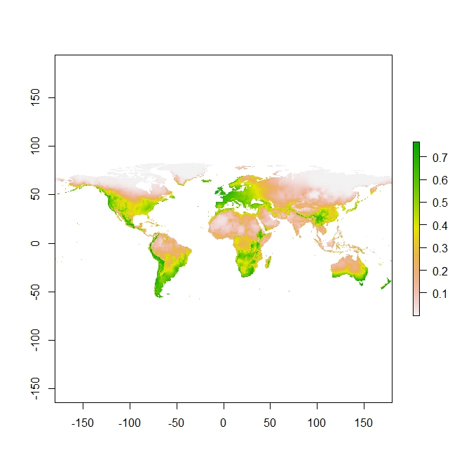

Fig 2: present global distribution of *Z. mays*

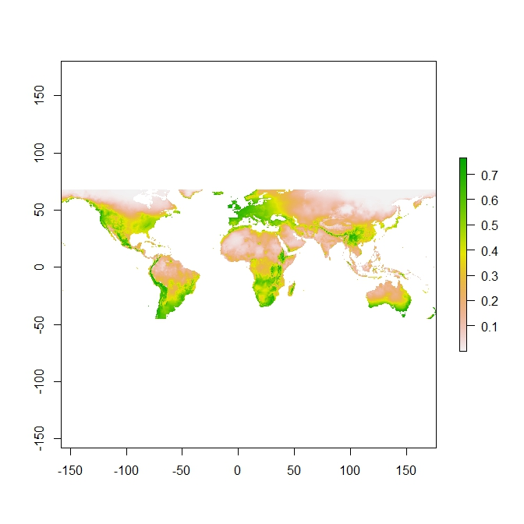

Fig 3: present global distribution of *Z. mays* clipped to training area

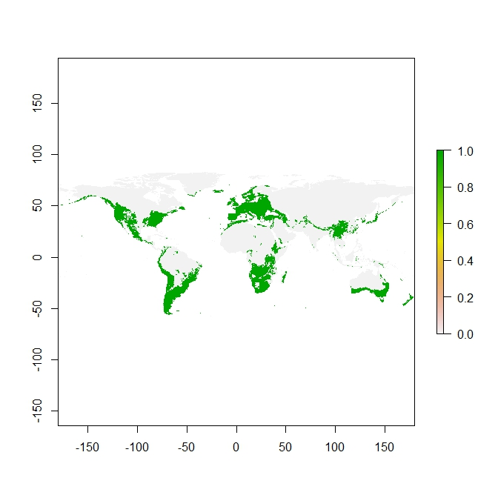

Fig. 4: present global distribution of *Z. mays*

Future distribution map

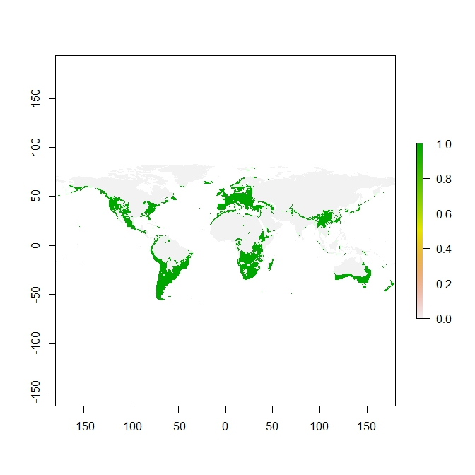

Fig. 5: global distribution of *Z. mays* for 2050 under scenario RCP 4.5

Model performance – AUC (Good model or not?)

The AUC value is 0.809 (fig. 6). This means that the model has useful applications. However the standard thresholds of AUC values indicating SDM accuracy do not apply. A solution would be to test the model AUC value against a null-model. The logistic threshold for the maximum training sensitivity plus specificity was 0.400 (table 2).

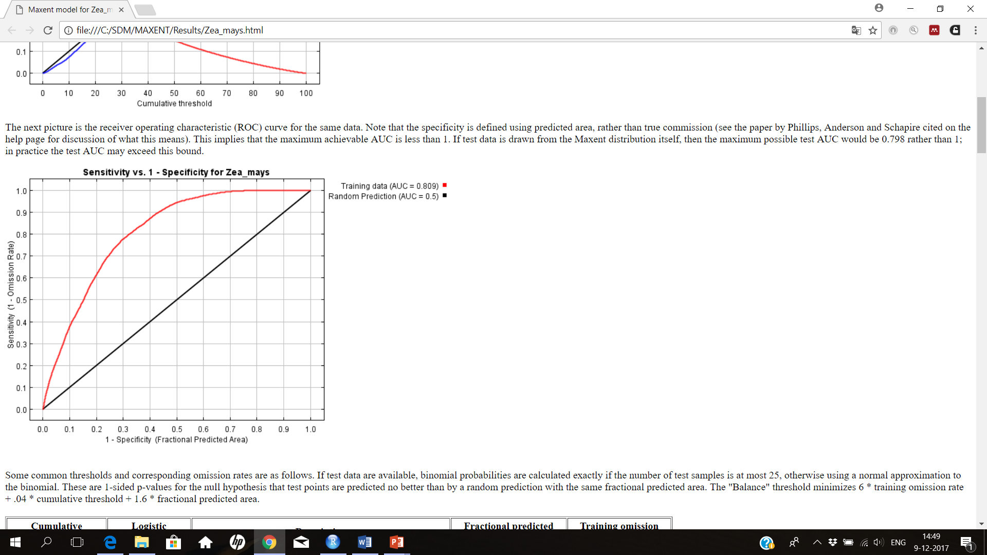

Fig. 6: sensitivity against 1-specificity for *Z. mays*

Table 2: logistic tresholds

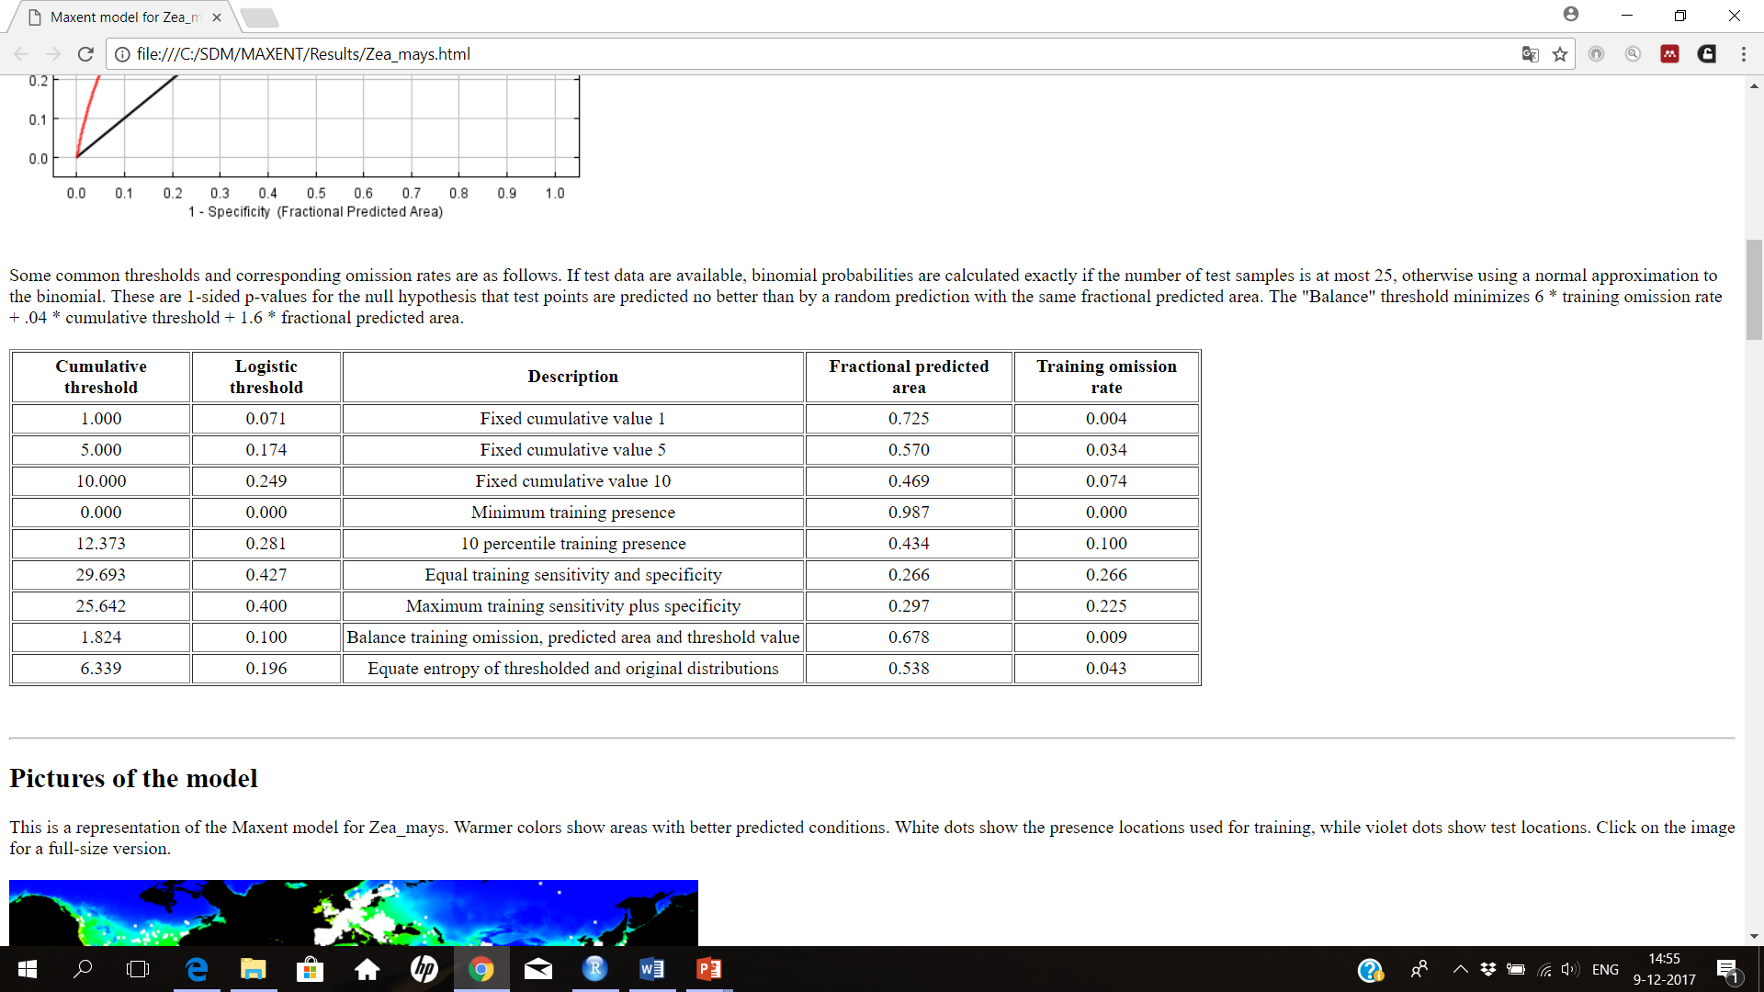

Variable importance table (what is driving the distribution patterns?)

Bio2 has with a percentage of 52.3% the highest contribution (table 3), but the permutation importance is zero. This is also visible in the upper curve of bio2 (fig. 7). The permutation importance is the highest for bio13 (table 3).

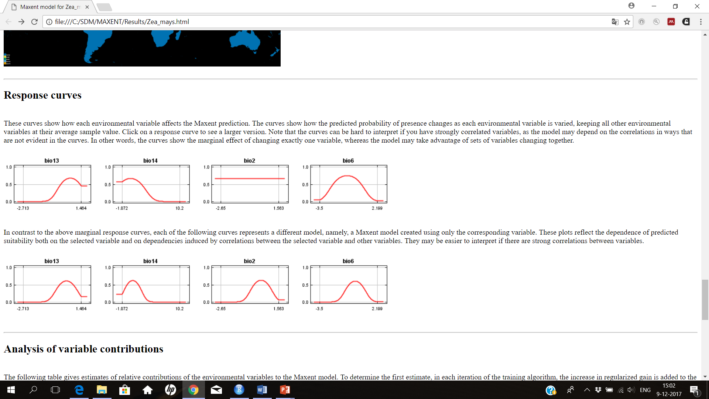



Fig. 7: the upper curves show the marginal effect of changing exactly one variable, each of the bottom curves represents a different model, namely, a MAXENT model created using only the corresponding variable.

Table 3: contribution and permutation importance of the different variables.

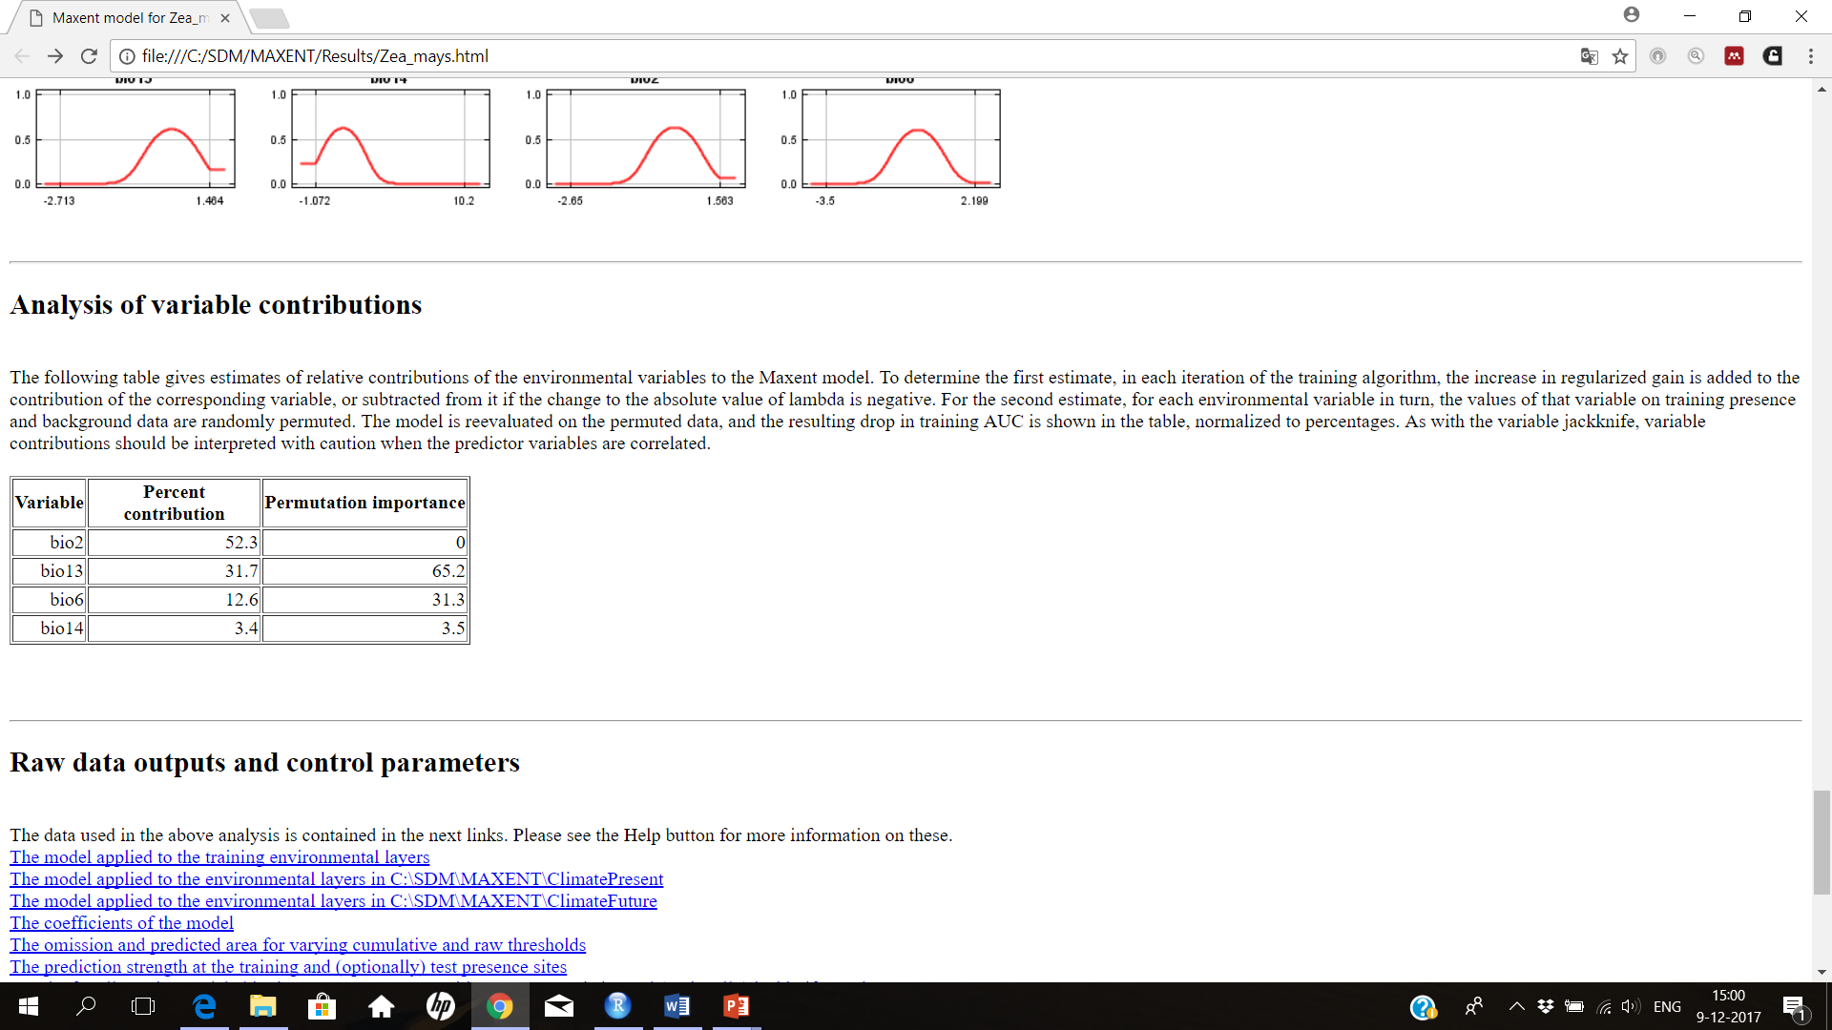

**Response to future scenario**

Future distribution change maps

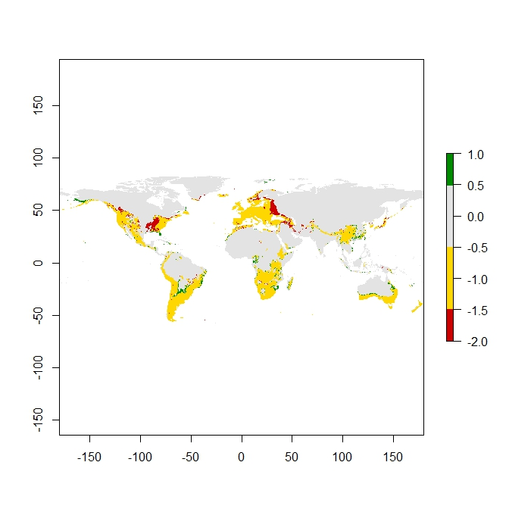

Fig. 8: difference between present and future habitat suitability for *Z. mays* on global scale. Grey is never suitable, yellow is remains suitable, red is lost and green is gained.

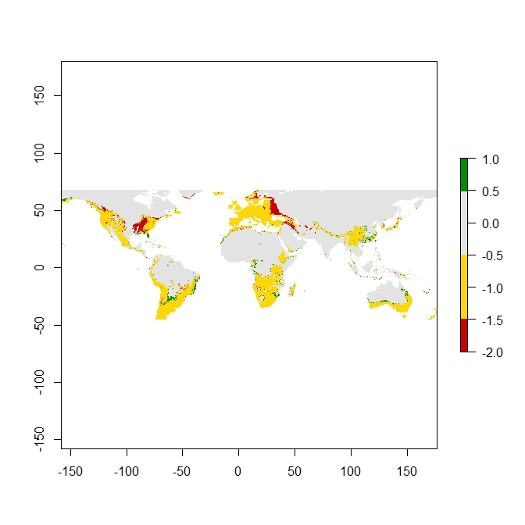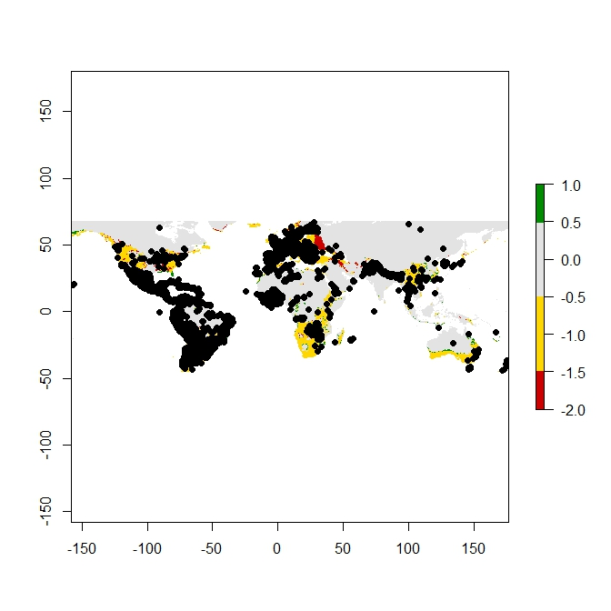

Fig. 9: difference between present and future habitat suitability for *Z. mays* on occurrence scale. Grey is never suitable, yellow is remains suitable, red is lost and green is gained. Upper figure without black occurrence dots, bottom figure with occurrence dots.

**Biological interpretation**

How is the distribution expected to change

*Z. mays* occurs now on places that would not be suitable according to the model, such as in parts of South America and in parts of Africa. *Z. mays* will lose much more suitable habitat on the Northern hemisphere than on the Southern hemisphere probably. In Europe is also a big part, where *Z. mays* does not occur, that becomes unsuitable. All continents visible in figure 9, except for Europe, gain some suitable habitat (there is some green to see on these continents, however it is sometimes very small). A big part of the world remains probably suitable for *Z. mays* in the future.

What could this mean for the biology of the species?

*Z. mays* has a big niche. The actual occurrence is bigger than the climatic envelope. Climate change under scenario RCP 4.5 for 2050 will reduce the amount of suitable habitat in the Northern hemisphere, but there stays a lot of suitable habitat in 2050 in the world, so the effects of climate change on *Z. mays* will be limited probably.

Usefulness of model

The model has useful applications, but it will not give the real distribution of *Z. mays*. The highest probability of occurrence is given, however information is missing and there are limitations at creating the model.

*Limitations and missing information*

A lot of uncertainty is created by initial dataset conditions, model classes, model parameters and boundary conditions. Moreover only four of the nineteen bio variables are taken into account. This is not much, but we cannot use them all, for if there are strong correlations, then we do not know which variable the driver is for the distribution of *Z. mays*. There is also information missing for the creation of the model. Only the abiotic conditions of a niche are taken into account. So species interactions, dispersal, demography, evolution, environment and physiology are missing. This all makes the model less reliable.

**References**

Merow, C. et al. 2013. A practical guide to MaxEnt for modeling species’ distributions: what it does, and why inputs and settings matter. – Ecography 36: 1058–1069.

Thomson, A.M., Calvin, K.V., Smith, S.J. et al. Climatic Change (2011) 109: 77. https://doi.org/10.1007/s10584-011-0151-4